Lab 01

Introduction to PSpice & Steady State and Transient Response of RL & RC Circuits

Name: Arsheel Abbas , Hussain Shah | Student ID: aa11163 , ss11677

Objective
The Objectives of this Lab are:
    - To get started with PSpice, drawing circuits and simulating circuits on OrCAD PSpice.
    - To investigate the Direct Current (DC) Steady State response of simple RL and RC circuits using OrCAD PSpice.
    - To investigate the transient behavior of RL and RC circuits using OrCAD PSpice. The CLOs, LDLs and PLOs mapped on in this lab are:
CLO | Description | LDL | PLO
CLO 1 | To analyze the relationship of current, voltage and frequency with impedance or series and parallel first order RC and RL networks. | PSY – 4 | PLO 1
CLO 4 | Demonstrate ethical values by complying with instructions and practicing organizational skills. | Aff-3 | PLO 8

Note: Read the manual and start doing your Lab, show all the tasks to the Lab Instructor/ Lab RA and this is your responsibility to get your rubric signed. In case if the rubric is unsigned task will be considered as not completed in Lab time.

Introduction
OrCAD PSpice is a SPICE circuit simulator application for simulation and verification of analog and mixed-signal circuits. PSpice is an acronym for Personal Simulation Program with Integrated Circuit Emphasis. SPICE is a general-purpose analog circuit simulator that is used to verify circuit designs and to predict the circuit behavior. PSpice is a PC version of SPICE and HSpice is a version that runs on workstations and larger computers. In the first task we are going to learn basics of PSpice

Task 1: Start the OrCAD
    - Start the OrCAD schematic capture program (Start → Cadence → Capture CIS Lite). Start a new project by selecting (File → New → Project) from the menu in the OrCAD Capture window. In the dialog that opens, provide a project name, a file path to where you want your project stored, and select the item “PSpice Analog or Mixed A/D”. Browse and specify the location of the working files. Similarly, A new folder can be created for a new project. Click OK.
      - Always create a new folder whenever you start work on a new project with OrCAD. Terrible things go wrong if you attempt to store more than one project in the same directory!

      - Save your work frequently and take regular backups of important circuits. It is a good idea to save these on are movable storage device.
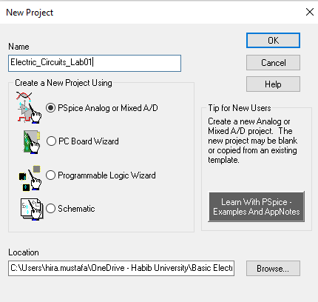
Figure 1.1

    - A dialog opens as shown in figure below that asks if you would like to create a blank project or start a new one based on an existing project. Since there is no existing project, you should choose “Create a blank project”.
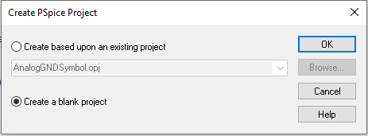
Figure 1.2
    - A new project has been created, now, a window will appear where you are going to create your first circuit.

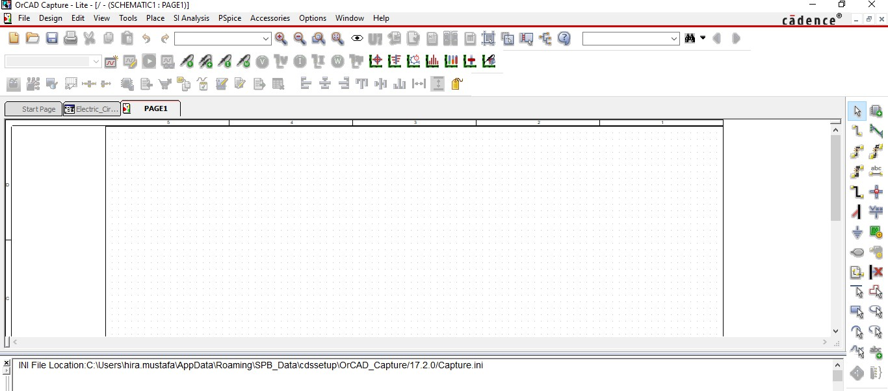
Figure 1.3: Environment of OrCAD PSpice

    - In order to simulate a circuit first step is to draw the schematic, this can be done by placing the components on the empty space provided. For this there is an option Go to “Place Part” a small window will open, now Libraries need to be added so that components may start appearing on the Part List.

Click the “Add Library” icon refer Figure below for the icon and a window will pop up. Select all the Libraries by pressing “Ctrl + A”, once all the libraries are selected Click Open.
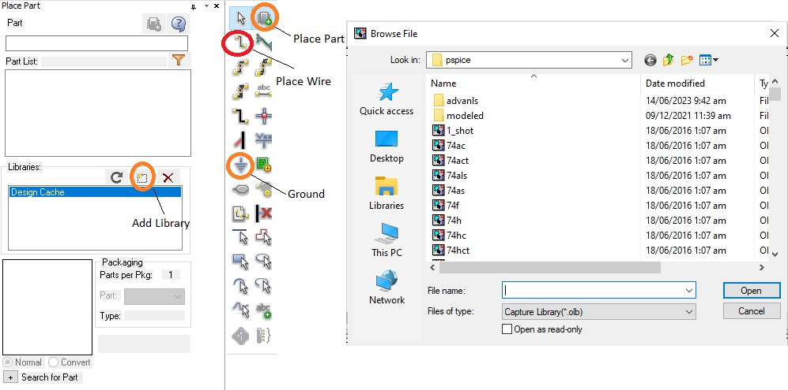

Figure 1.4: Place Part

    - Here is the list of standard components that will be required in today’s Lab.

Table 1.1

Component Name | Component Name in PSpice
Resistor | R/ANALOG
Capacitor | C/ANALOG
Inductor | L/ANALOG
Simple DC Voltage Source | VDC/SOURCE
Simple Voltage Source; AC,  DC, Or Transient may be Specified | VSRC/SOURCE
Ground | 0/CAPSYM¹
DC Current Source | ISRC
VSIN | Transient sine Voltage Source
V_PULSE | Pulse Voltage Source
VAC | Simple AC Voltage Source

Check Point of Task 1

Instructor/RA Signature:

What is the abbreviation of PSpice? Why are we using PSpice why not HSpice?

Personal Simulation Program with Integrated Circuit Emphasis. Pspice is used because of its User-Friendly GUI, Built in libraries and mixed signal PCB components.

¹ In Order to select correct Ground on PSpice see the pallet on the right and click the symbol of GND. The PSpice does not simulate the circuits without Ground being provided. Make sure to add ground in every circuit.

DC Steady State Response
DC Steady State means that the circuit has been active or running for a long time. For power dissipating elements like resistors, this does not affect much, but for energy storing elements such as inductors and capacitors it changes how they behave. The DC steady state response of RL and RC circuits are essentially opposite of each other, i.e., once steady state is reached, capacitors become open circuits, which means that there is a break in the circuit, in D.C. steady state, while inductors become short circuits, which means they become a wire, in D.C. steady state.
A good way to remember this is to understand why this occurs. Capacitors store charge in an electrostatic field. Charge will continue to build up on the plates until the voltage gets to a maximum (usually equaling the voltage of the voltage source) and can no longer increase/change. Given that the current through a capacitor is 𝑖 = 𝐶(𝑑𝑣/𝑑𝑡), so capacitance times the derivative of the voltage across the capacitance, if the voltage is at a maximum, 𝑑𝑣/𝑑𝑡 = 0 since the voltage is no longer changing, so 𝑖 = 0 and it’s an open circuit. For inductors they store energy in a magnetic field, which is induced as current runs through their loops (an inductor, in its most basic form, is just a looped wire). Its voltage is dependent on a changing current, 𝑣 = 𝐿(𝑑𝑖/𝑑𝑡), where L is the inductance and 𝑑𝑖/𝑑𝑡 is the derivative of the current. At DC steady state, the current no longer changes (it reaches a maximum through an inductor), so 𝑑𝑖/𝑑𝑡 = 0 so the voltage is 0.

Time Constant
The time constant τ (the Greek letter tau) has units of seconds (verify, for both RC and R/L), and it governs the “speed” of the transient response. Circuits with higher τ take longer to get close to the new steady state. Circuits with short τ settle on their new steady state very quickly. More precisely, every time constant τ, the circuit gets 1 − 𝑒⁻³ ≅ 65% of its way closer to its new steady state.
Memorizing this fact can help you draw graphs involving exponential decays quickly. After 3𝜏, the circuit will have gotten 1 − 𝑒⁻⁵ ≅ 95% of the way, and after 5𝜏, more than 99%. So, after a few time constants, for practical purposes, the circuit has reached steady state. Thus, the time constant is itself a good rough guide to “how long” the transient response will take.
Practically, steady state is reached after five-time constants (Greek letter tau τ) i.e., 5𝜏. The time constant for an RC circuit is simply the effective capacitance times the effective resistance,

Time constant of the Capacitor, 𝜏 = 𝑅𝐶

In an RL circuit, the time constant is the effective inductance divided by the effective resistance,

Time constant of the Inductor, 𝜏 = 𝐿/𝑅

Task 2: To examine steady state DC response of a RL Circuit on PSpice
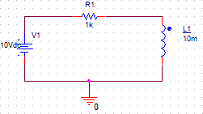
Figure 1.5: Schematic for RL Circuit
- Figure 1.5 shows the schematic for a simple RL circuit. Construct this circuit on PSpice. Start the circuit definition by placing some resistors as you desire to make a circuit. Select “Part” from the “Place” menu to open a dialog that allows you to choose the part you want to use. Parts are kept in various “libraries” for example, sources are in the SOURCE library and as we have already added all the libraries, we can simply write part name in the search bar and use the part. Refer Table 1.1.

- When you are satisfied that you have the right part, double click on the “R” item in the list. You will be returned to the drawing window. The symbol of a resistor will be attached to the cursor. Drag it to a point towards the left side of the drawing window and click the left mouse button to “place” it. The resistor will have default name of “R1” and a default value of 1k (1 Ω).
- When finished with the inductor, click the right mouse button and choose “End mode” from the popup menu or hit the escape key to get rid of the inductor attached to the cursor. If you don’t like the location of a resistor or an inductor, you can select it and drag it to a new spot.

- To change the value of a component, double-click on it which opens a new window. In value field, type the required value of component, and select OK. To change the orientation, right-click the mouse and choose “rotate” from the pop-up list. Refer Figure 1.6 for the correct orientation of the inductor.

- Add an inductor to the drawing window and set its value to 10mH. Refer Table 1.1 to see the component name.

- Use the same procedure to place a DC voltage source (“VDC” or “VSRC” in the source library) in the drawing window and set its value to 10V.

- Now that all parts are placed, we can use the wire tool to connect the them. Select the “Place Wire” item from the “Place” menu (or click on the second item on the left side of the vertical tool-bar) to activate the wire tool, refer Figure 1.4. The cursor turns into a cross-hair.

- Every PSpice circuit needs a ground connection. To add a ground, use the menu (Place → ground) or click on the “ground” item in the vertical tool-bar or press key G, refer Figure 1.4. A dialog opens. Choose the 0/CAPSYM. Place the ground in the desired place in the drawing and then use the wire tool to connect it into the circuit.

- Select a current marker from PSpice tool-bar and place it on the leg of an element (example first leg of inductor L1) where you want to monitor the amount of current flow. The complete schematic with marker placed on the inductor is shown in Figure 1.6a.
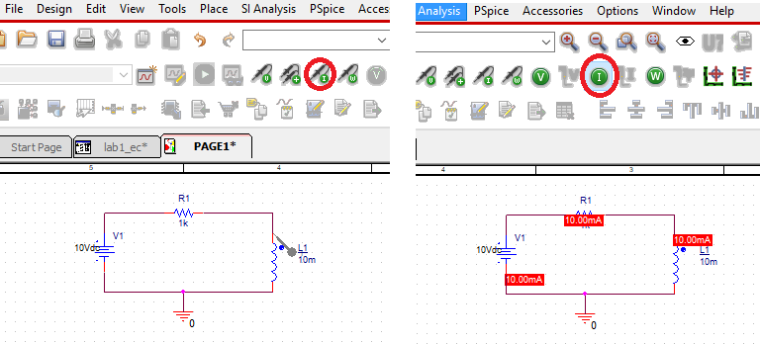
Figure 1.6a: Current Marker on the inductor L1 Figure 1.7b: Current value on Circuit

- Now that the circuit schematic is completed, you are ready to tell PSPICE how to analyze the circuit. From the “PSPICE” menu, select the menu item “New Simulation Profile” (or choose the first item in the second horizontal tool-bar). A small dialog appears that asks you to give a name to the simulation profile you are creating. Choose a clever name like “sim1” and click on “Create”.

- Another dialog with many tabs appears. The only tab that is important at this point is the one labeled “Analysis”. It is important to understand the different analysis types, which are selected using the pop-up menu under the heading “Analysis Type”.

There are four options in that menu:

  - Bias point: This calculates the DC values for all the node voltages and branch currents in the circuit. This corresponds to using the DC multi-meter to probe each voltage and current in the circuit. When using this option, the voltages and/or currents will be displayed directly on the circuit diagram.

We usually do not use current markers for DC voltages, only select the analysis type to BIAS POINT and you can run the simulation. The voltages or currents will directly appear on the circuit diagram, it is necessary to specify which parameter you want to have displayed. Values of current for the circuit under observation have been displayed on the circuit diagram, Refer Figure 1.6b and observe that the option of current has been selected.
  - DC Sweep: Similar to bias point, expect that the value of one DC source in the circuit can be varied over some range, and the currents and voltages in the circuit are calculated at each DC source value. This allows you to make a plot of a voltage or current in the circuit as a function of the DC source voltage.

  - AC Sweep: This uses a constant amplitude AC source whose frequency can be varied over some range. The AC (complex) voltages and currents are calculated at each frequency. This allows you to make a plot of the magnitude and/or phase of any voltage or current in the circuit as a function of frequency.
  - Time Domain (Transient): This calculates the currents and voltages in a circuit at various points in time, allowing you to make a plot of a voltage or voltage as a function of time. The resulting plot would correspond to what you might see on the oscilloscope if you were measuring the circuit in lab. Each of the analysis options requires the proper choice of source(s) in the circuit. (This is why there are so many different source options). Obviously, the DC analysis require DC source, VDC and IDC being the most common. The AC sweep uses the VAC or IAC sources, for which only the amplitude is specified. Time domain analysis requires sources whose time behavior is well specified, and so there are more options and the sources themselves require more parameters. Two of the more commonly used time domain sources are VSIN, which is a sine function, with specified amplitude and frequency and VPULSE, which is a square wave requiring a number of parameters to define the shape of the pulse.
*The summarized details of the simulation options along with its application are provided in the Appendix of this Lab.
- Drop down the options in Analysis Type and select DC Bias Point. Click “Ok”, refer to the Figure below.
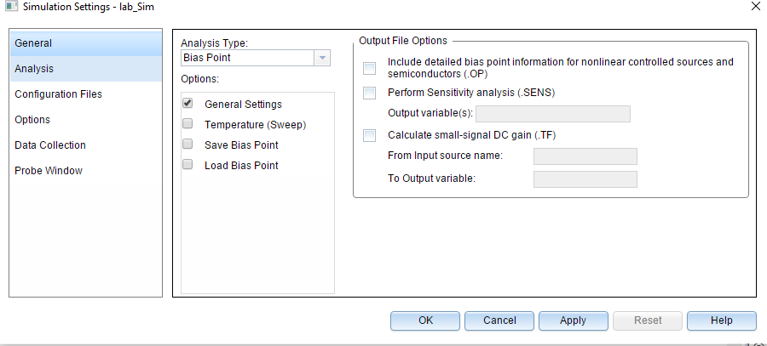

Figure 1.8: Analysis Type
- Go to the main menu bar and Click “Run PSpice” icon. In order to display the value of current or voltage directly on the circuit Go to step 12 a and read again. You may remove the current marker.

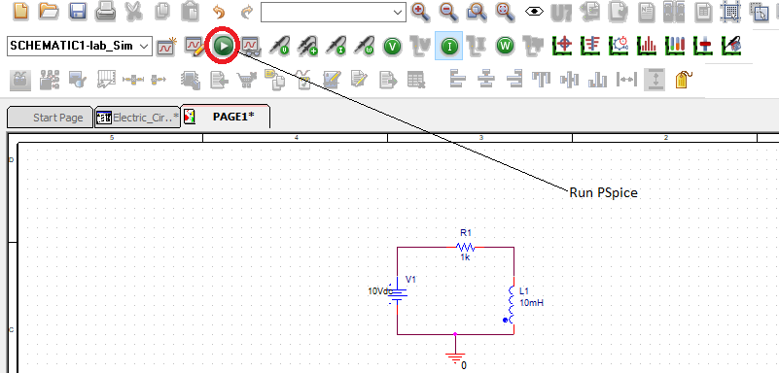

Figure 1.9: Run button

- Note the value of Current and note the simulated value in Table 1.2.
- Calculate the time constant and inductor steady state current and record the values in Table 1.2.

Table 1.2

τ (calculated) | 10µs
IL (Calculated) | 10mA
IL (Simulated) | 10mA

Task 3: To examine steady state DC response of a RC Circuit on PSpice
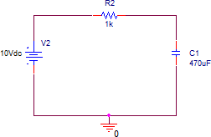
Figure 1.10: Schematic for RC Circuit
- Figure 1.9 shows the schematic for a simple RC circuit. Construct this circuit on PSpice and simulate. Note the Capacitor Voltage in Table 1.3
- Calculate the time constant and capacitor steady state voltage and record the values in Table 1.3.

Table 1.3

τ (Calculated) | 0.47s
VC (Calculated) | 10V
VC (Measured) | 10V

Transient Response of Capacitor and Inductor
Resistor–capacitor (RC) and resistor–inductor (RL) circuits are the two types of first-order circuits: circuits consists either one capacitor or one inductor. What happens between the time the circuit is powered up and when it reaches steady-state? In many applications, these circuits respond to a sudden change in an input; for example, a switch opening or closing, or a digital input switching from low to high. Just after the change, the capacitor or inductor takes some time to charge or discharge, and eventually settles on its new steady state. The immediate response of the circuit after a sudden change is called the Transient response.

In simple words, the transient response is the circuit’s temporary response that will die out with time. It is followed by the steady state response, which is the behavior of the circuit a long time after an external excitation is applied.

In any first-order circuit, if there is a sudden change at 𝑡 = 0, the transient response for a voltage is given by:

𝑣(𝑡) = 𝑣(∞) + [𝑣(0 +) − 𝑣(∞)]𝑒^{−𝑡/𝜏},

Where 𝑣(∞) is the (new) steady – state voltage; 𝑣(0+) is the voltage just after time 𝑡 = 0; 𝜏 is the time constant, given by 𝜏 = 𝑅𝐶 for a capacitor or 𝜏 = 𝐿/𝑅 for an inductor, and in both cases 𝑅 is the resistance seen by the capacitor or inductor. The transient response for a current is given by:

𝑖(𝑡) = 𝑖(∞) + [𝑖(0 +) − 𝑖(∞)]𝑒^{−𝑡/𝜏},

Where 𝑖(∞) is the (new) steady – state voltage; 𝑖(0+) is the voltage just after time 𝑡 = 0;
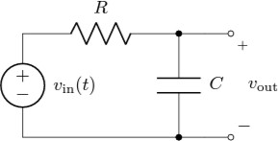

Figure 1.11

For example: Consider the RC circuit in Figure 1.10, whose voltage source provides:

𝑉𝑖𝑛(𝑡) = 0 𝑡 < 0
𝑉𝑖𝑛(𝑡) = 10 𝑡 ≥ 0

A few observations, using steady state analysis. Just before the step-in 𝑉𝑖𝑛 from 0𝑉 𝑡𝑜 10 𝑉 at 𝑡 = 0,
𝑉𝑜𝑢𝑡(0−) = 0𝑉. Since 𝑉𝑜𝑢𝑡 is across a capacitor, 𝑉𝑜𝑢𝑡 just after the step must be the same:
𝑉𝑜𝑢𝑡(0+) = 0𝑉. Long after the step, if we wait long enough the circuit will reach steady state, then
𝑉𝑜𝑢𝑡(∞) = 10𝑉.

Task 4: To examine the transient behavior of a RC Circuit on PSpice (Hardware)

- Using Figure 1.10 with Vin = 10 V, R = 27 kΩ, and C = 470 µF, calculate the time constant and record it in Table 1.5.
- Build the circuit in OrCAD PSpice, replace the DC voltage source (Vin) with VPULSE Source²; The parameters for VPULSE Source are discussed in Table below.

Table 1.4: Explanations of different parameters associated with the Pulse waveform

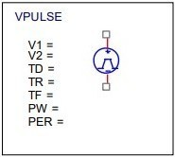 | V1 | Low Level Voltage
 | V2 | High Level Voltage
 | TD | Time delay for first transition
 | TR | Time it takes to go from low level to high level; Rise  Time
 | TF | Time it takes to go from high level to low level; Fall  Time
 | PW | Time span for which waveform is high during one  period; Pulse width
 | PER | Time period of waveform

- Calculate the time constant and expected steady state capacitor voltage and record in Table 1.5.
Table 1.5

τ (calculated) | 12.69s
𝑉𝑜𝑢𝑡 or 𝑉𝑐 (Calculated) | 10V

- Set its parameters as V₁ = 0, V₂ = 10, TD = 0, TR = 0.001, TF = 0.001, PW = 119.998,
PER = 240.

2 VPULSE is used to generate Square and Triangular wave in OrCAD PSpice.

- Draw the pulse with above parameters in the box below and show this to your RA/instructor.

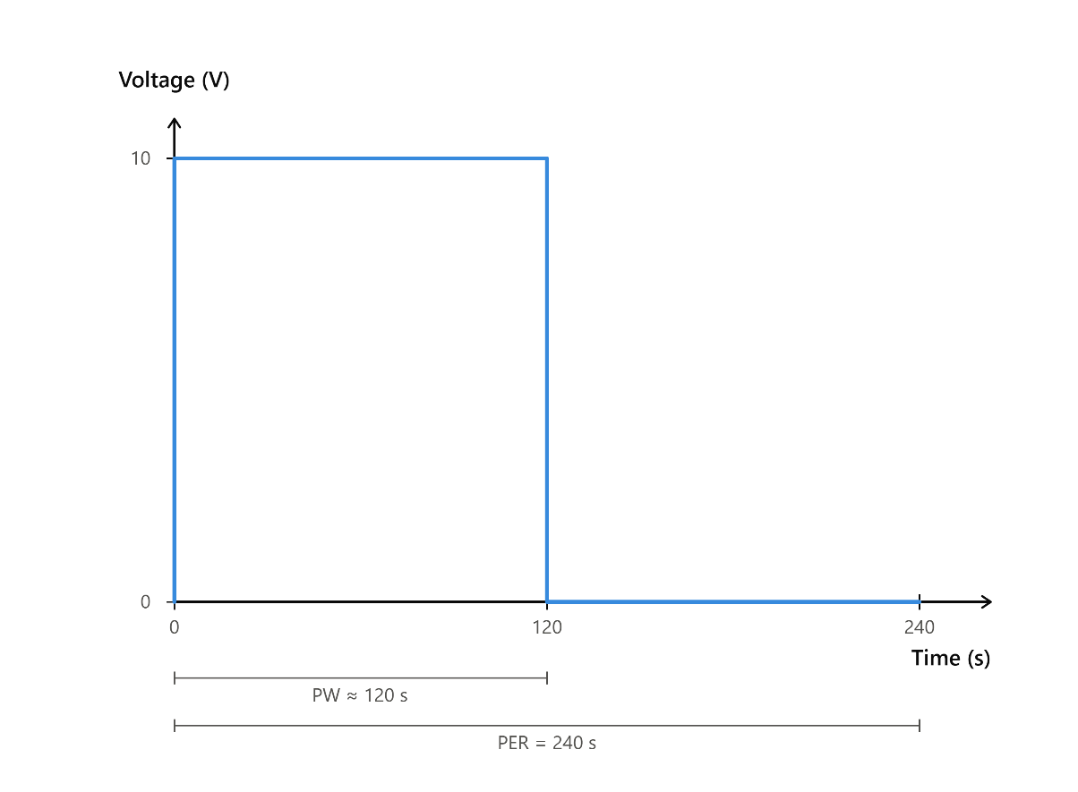

- Add voltage markers at VPULSE Source and capacitor.
- Run Time Domain (Transient) Analysis for 250s. A simulation window will appear click on this symbol and click anywhere on the simulation you will get a marker. Place the marker to the desired point and note the readings from the section provided in Figure 1.12. Record the capacitor charging and discharging voltage in Table 1.6.

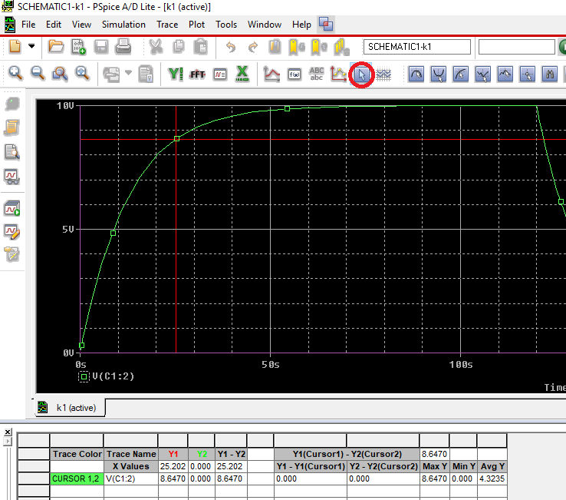
Figure 1.12: Capacitor charging trend with current marker on 25.2s and Voltage value 8.667V Table 1.6
Time (s) | Charging Voltage (V) | Time (s) | Discharging Voltage (V)
0 | 0V | 120 | 9.605V
10 | 5.4457 V | 130 | 4.583V
20 | 7.9579V | 140 | 2.0421V
30 | 9.0762V | 150 | 907.618mV
40 | 9.586V | 160 | 404.162mV
50 | 9.813V | 170 | 170.181mV
60 | 9.918V | 180 | 82.818mV
70 | 9.963V | 190 | 37.488mV

- Plot the graph of charging and discharging of capacitor for one complete cycle (with proper labelling).

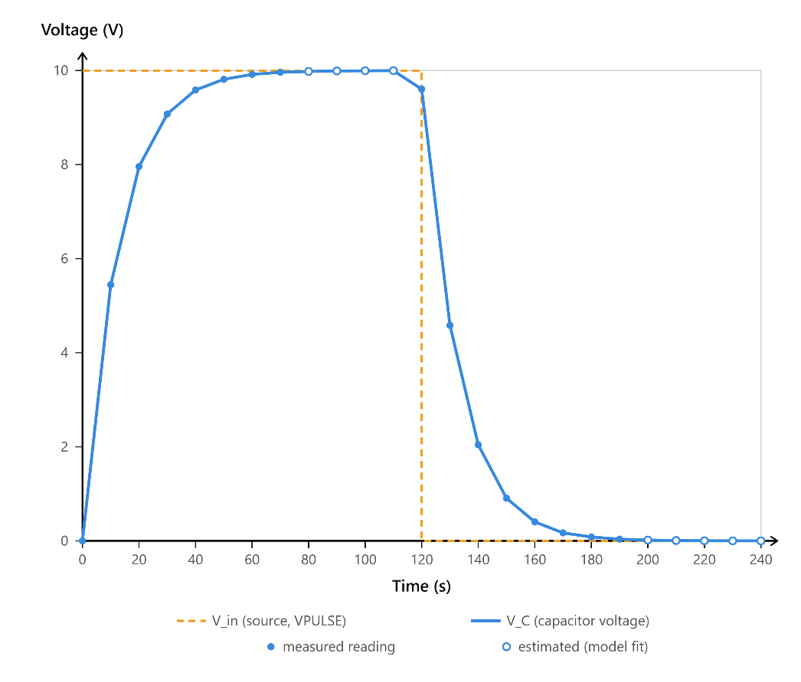

Post Lab
Task 5: To examine the transient behavior of a RL Circuit on PSpice
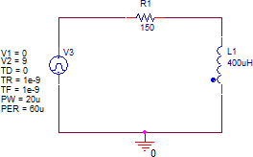

Figure 1.13: Schematic for RL Circuit
- Using Figure 1.13, calculate the time constant and record it in Table 1.7. Also, calculate and record the expected steady state inductor current.
Table 1.7

τ (calculated) | 2.67us
IL (Calculated) | 60mA

- Implement the circuit using OrCAD Capture. PSpice voltage source model name to generate Square and Triangular wave is VPULSE. The parameters for VPULSE Source are discussed in Table 1.4.

- Set the parameters as V1 = 0, V2 = 9, TD = 0, TR = 1ns, TF = 1ns, PW = 20u, PER = 60u.

- Draw the pulse with above parameters in the box below and show this to your RA/instructor

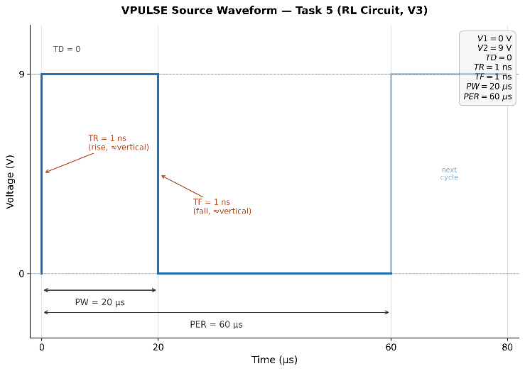

- Add voltage markers across VPULSE source and Run Time Domain (Transient) Analysis for 60us.
- Add a current marker with inductor. Run Time Domain (Transient) Analysis for 60us.
- Record the inductor charging and discharging voltage in Table below.

Table 1.8

Time (us) | Charging Current (mA) | Time (us) | Discharging Current (mA)
0 | 0 | 25 | 8.9465mA
5 | 51.054mA | 30 | 1.3551mA
10 | 58.651mA | 35 | 202.511uA
15 | 59.798mA | 40 | 30.107uA
20 | 60mA | 45 | 4.4489uA
- |  | 50 | 652.750nA
- | - | 55 | 96.545nA
- | - | 60 | 14.265nA

- Plot of charging and discharging of inductor for one complete cycle (with proper labelling)

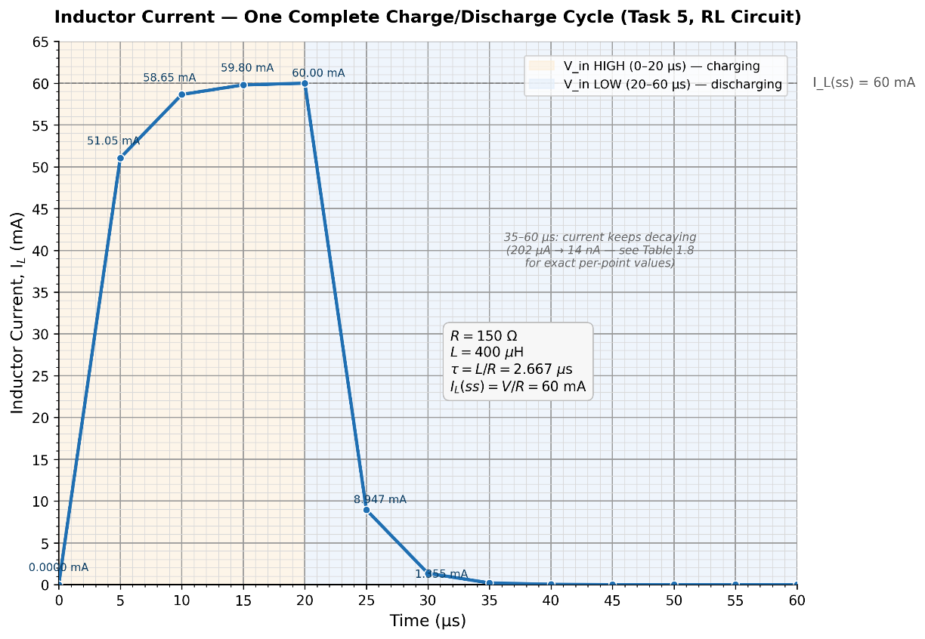

- Now replace 400µH inductor with 1000µH inductor and run the Time Domain (Transient) Analysis. Discuss the reason behind the change in results in detail, considering the input provided.

When the 400 µH inductor is replaced with a 1000 µH inductor, the simulation shows that the
current only peaks at roughly 57 mA and fails to reach the 60 mA steady-state maximum.
This occurs because increasing the inductance significantly increases the circuit's time constant,
which causes the inductor to resist changes in current more strongly and charge at a much
slower rate. Because the input VPULSE source is configured with a narrow pulse width of
only 20 microseconds, the power simply shuts off before the slower circuit has enough time
to fully charge, forcing the inductor to discharge prematurely.

Appendix: Guide to PSpice

Analysis Types in PSpice

Analysis types PSpice can be applied to perform include DC analysis, AC analysis, transient analysis and advanced analysis. Each type of analysis contains their own analysis types that are shown in the following table.

DC  Analysis | DC sweep analysis | To sweep a source, a global parameter, a model parameter or the temperature via a range of  values.
DC  Analysis | Bias point analysis | To implement any analysis.
DC  Analysis | DC sensitivity analysis | To calculate and report the sensitivity of one node voltage to each device parameter.
AC  Analysis | AC sweep analysis | To calculate small-signal response.
AC  Analysis | Noise analysis | To calculate and report device noise and total output and equivalent input noise.
Transient Analysis | Parametric analysis | To perform multiple iterations of a specified standard analysis.
Transient Analysis | Temperature analysis | To return standard analyses set in the Simulation Settings dialog box at different temperatures.
Transient Analysis | Monte Carlo analysis | To calculate the circuit response to changes in part values.
Advanced Analysis | Worse case analysis | To find the worst probable output of a circuit or system.

FAQs
Q. Difference between VAC and VSIN?
Ans: VAC is used for primarily AC analysis, while VSIN can be used for both sin and transient analysis. VSIN allows you to set offset, frequency in addition to peak voltage.

Q. When capacitor’s charging time to the 99% of the voltage is 5𝜏, what should be the discharging time?
Ans: The Capacitor takes 5𝜏 to discharge.

Q. In PSpice, there is a dot in inductor’s symbol, what does this dot represent?
Ans: In OrCAD PSpice, a dot near an inductor symbol typically represents the polarity or the winding direction of the inductor. The dot is used to indicate the reference polarity of the inductor's voltage across its terminals.
When two or more inductors are connected together, the dots help to indicate the relative winding direction or polarity alignment between them. If the dots are on the same side of the inductor symbols, it suggests that the winding directions are in the same direction, leading to positive mutual inductance. Conversely, if the dots are on opposite sides, it indicates that the winding directions are in opposite directions, resulting in negative mutual inductance.
Understanding the polarity or winding direction is important when modeling circuits involving inductors, as it affects the behavior of the circuit, particularly in terms of phase relationships and mutual inductance effects.

Assessment Rubric
Lab 01

Introduction to PSpice & Steady State and Transient Response of RL & RC Circuits

Name: | Student ID:

Points Distribution

Task No. | LR 2  Simulation | LR5  Results/Plots | LR 10  Analysis | LR9  Report
Task 1 | - | - | - | /10
Task 2 | /5 | /5 | - | -
Task 3 | /5 | /5 | - | -
Task 4 | /5 | /15 | /10 | -
Task 5 (Post Lab) | /5 | /15 | /10
Total | /20 | /40 | /20 | /10
CLO Mapped | CLO 1 | CLO 1 | CLO 1 | CLO1

Affective Domain Rubric |  | Points | CLO  Mapped
AR 7 | Report Submission | /10 | CLO 4

CLO (LDL) | Total Points | Points Obtained
1 – (Psy-4) | 90
4 – (Aff-3) | 10
Total | 100

For description of different levels of the mapped rubrics, please refer the provided Lab Evaluation Assessment Rubrics and Affective Domain Assessment Rubrics.

Lab Evaluation Assessment Rubric
# | Assessment Elements | Level 1: Unsatisfactory  Points 0-1 | Level 2: Developing  Points 2 | Level 3:Good Points 3 | Level 4:Exemplary Points 4
LR1 | Circuit Layout | Connections between circuit components are mostly wrong. Circuit layout is cluttered. Needs guidance to make correct equipment/ component connections. | Few of the connections made between circuit components are wrong. Circuit layout is not neat and clean as per standards. | Circuit layout and connections are correct but not all connections are neat and clean as per standards. | Neat, clean and correct connections of all the circuit components/ equipment are made as per standard circuit diagram.
LR2 | Program/Code/ Simulation Model/ Network Model | Program/code/simulation model/network model does not implement the required functionality and has several errors. The student is not able to utilize even the basic tools of the software. | Program/code/simulation model/network model has some errors and does not produce completely accurate results. Student has limited command on the basic tools of the software. | Program/code/simulation model/network model gives correct output but not efficiently implemented or implemented by computationally complex routine. | Program/code/simulation /network model is efficiently implemented and gives correct output. Student has full command on the basic tools of the software.
LR3 | Troubleshooting | Unable to identify the fault/minimal effort show in troubleshooting. | Able to identify the fault but unable to remove it. | Able to identify the fault but partially removes it. | Able to identify the fault and takes necessary steps and actions to correct it.
LR4 | Data Collection | Measurements are incomplete, inaccurate and imprecise. Observations are incomplete or not included. Symbols, units and significant figures are not included. | Measurements are somewhat inaccurate and imprecise. Observations are incomplete or vague. Major errors are there in using symbols, units and significant digits. | Measurements are mostly accurate. Observations are generally complete. Minor errors are present in using symbols, units and significant digits. | Measurements are both accurate and precise. Data collection is systematic. Observations are very thorough and include appropriate symbols, units and significant digits and task completed in due time.
LR5 | Results & Plots | Figures/ graphs / tables are not developed or are poorly constructed with erroneous results. Titles, captions, units are not mentioned. Data is presented in an obscure manner. | Figures, graphs and tables are drawn but contain errors. Titles, captions, units are not accurate. Data presentation is not too clear. | All figures, graphs, tables are correctly drawn but contain minor errors or some of the details are missing. | Figures / graphs / tables are correctly drawn and appropriate titles/captions and proper units are mentioned. Data presentation is systematic.
LR6 | Calculations | Formulae used and/or calculations are incorrect. Units are not mentioned with results. | Formulae used are correct but there are few mistakes in calculation which lead to incorrect results. | Formulae used and end results are correct. Complete working steps are not shown. Proper units are not mentioned with results. | Formulae used, end results and all calculations are correct with all the intermediate steps clearly shown. Units are mentioned with results.
LR9 | Report | All the in-lab tasks are not included in report and / or the report is submitted too late. | Most of the tasks are included in report but are not well explained. All the necessary figures / plots are not included. Report is submitted after due date. | Good summary of most the in-lab tasks is included in report. The work is supported by figures and plots with explanations. The report is submitted timely. | Detailed summary of the in-lab tasks is provided. All tasks are included and explained well. Data is presented clearly including all the necessary figures, plots and tables.
LR10 | Analysis | Results are not interpreted or are analyzed incorrectly. | Analysis of the obtained results is incomplete. Conclusions are not drawn. | Results are analyzed and concluded but are not well explained and justification is not provided with the help of reasoning. | Results are well analyzed supported with reasons. Good comparison is made between the theoretical and experimental results with correct and useful conclusion.
LR11 | Design | Proposed design is unsubstantiated or does not satisfy most of given constraints. The breakdown of system into features is incomplete and still at lower resolution. | Justification for proposed design is weak, and it only satisfies some constraints. The breakdown of system is missing some features and resolution is not appropriate at some places. | Proposed design is substantiated, preferably through proper analysis, and satisfies most given constraints. The breakdown of system into features seems complete, but resolution is not appropriate at some places. | Proposed design is substantiated, preferably through proper analysis, and satisfies all given constraints. The breakdown of system into features seems complete and at appropriate resolution, given students' level.

